Project 1 – ANSUR II Analysis
Sarah Mzee
PBHLT 7101
March 12, 2026

Introduction
This analysis was conducted to create an analytical dataset and perform exploratory data analysis of demographic and anthropometric data in the ANSUR II dataset. The project is based on body measurements (stature, trunk circumference, and weight), the relationships among these measures for females and males, between females and males, and across various Army components, and how measured values relate to self-reported height and weight. Derived measures, such as the body mass index (BMI), and other constructed variables needed to prepare and interpret data are also part of the analysis.
The information is based on the 2012 U.S. Army Anthropometric Survey (ANSUR II), a study conducted by the Natick Soldier Research, Development and Engineering Center, taking place in October 2010-April 2012. ANSUR II was intended to capture the total force of the U.S. Army, which was the Regular Army, Army Reserve, and Army National Guard. Variables included in the course dataset of this project, such as anthropometric measurements, self-reported height and weight, sex, age, Army component, branch, writing preference, installation, and race/ethnicity, are a subset of ANSUR II. The imported class dataset had 7,031 observations and 29 variables. After filtering for participants younger than 18 years, the analysis dataset comprised 7,029 observations. The dataset contains continuous anthropometric measures, categorical demographic variables, and self-reported measures to be compared with the measured ones.
Data Analysis Plan
The analysis began with data cleaning and preparation, which involved eliminating ineligible data, imputing missing values, and creating new variables, including BMI and categorical variables. Thereafter, descriptive statistics were generated for the sample's demographic and anthropometric data. Anthropometry was analyzed to examine distributions and identify possible outliers or low-quality data.
Stratified analyses were used to compare differences between genders and Army components. Correlations were computed among various stature measures. Further tests involved comparing measured and self-reported values to assess the possibility of reporting bias. Body composition variation was further examined by derived variables BMI and body type. All analyses were conducted in Stata, and the results were summarized in tables, figures, and narrative.
1. Data Preparation
The first dataset had 7,031 observations. Individuals under 18 years of age were excluded, resulting in a final sample of 7,029 observations. Anthropometric variables were coded as -99 to Stata's special missing value (. a) to ensure correct analysis. Duplicate IDs were detected via a duplicate-flag variable, but they were retained because they indicate repeated measurements rather than data-entry errors.
More variables were generated, such as weight in kilograms (corrected from kg × 10) and height in centimeters. The variable for writing preference was converted to a numeric format using the encode command, enabling statistical analysis while preserving the category labels. A season variable was developed based on the month of measurement, i.e., the test date. The data were classified into winter, spring, summer, and fall. This variable was developed to permit the possible evaluation of seasonal trends in anthropometric measurements.
The waist-to-height ratio (WHtR) was used to create a body type variable, defined as the ratio of waist circumference to stature. There were sex-specific cutoffs to determine stigma within three categories: lean, average, and high adiposity. Males and females were given different thresholds to indicate physiological differences in body composition.
2. Descriptive statistics
The sample consisted of 7,029 individuals, of which 68.96% were male and 31.04% were female. The majority of participants were from the Regular Army (54.35%), followed by the National Guard (41.27%) and Army Reserve (4.38%). The mean age of participants was 30.07 years (SD = 8.80), ranging from 18 to 58 years. The average height was 173.60 cm (SD = 9.79), and the average weight was 80.02 kg (SD = 15.62).
The distribution of height appeared approximately normal, while weight showed slight right skew with some higher-value outliers.
Table 2.1-1. Sex Distribution
Sex | Frequency | Percent
Male | 4,848 | 68.96%
Female | 2,181 | 31.04%
Total | 7,029 | 100%

Table 2.1-2. Army Component

Component | Frequency | Percent
Regular Army | 3,820 | 54.35%
National Guard | 2,903 | 41.27%
Army Reserve | 308 | 4.38%
Total | 7,029 | 100%

Table 2.1-3. Continuous Variables

Variable | Mean | SD | Min | Max
Age (years) | 30.07 | 8.80 | 18 | 58
Height (cm) | 173.60 | 9.79 | 142 | 239
Weight (kg) | 80.02 | 15.62 | 35.8 | 144.2

Figure 2.1-1. Height Distribution
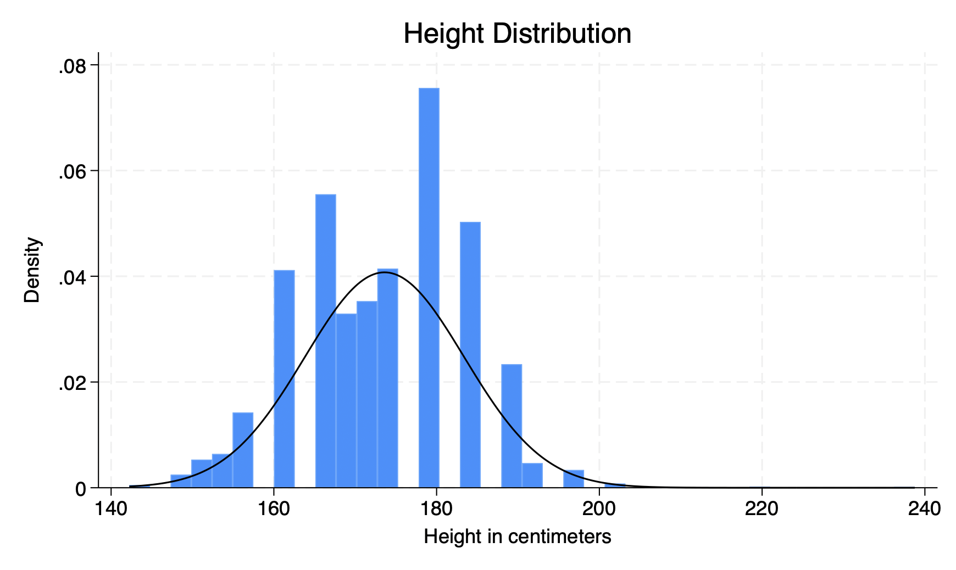
Height distribution appears approximately normal.

Figure 2.1-2. Weight Distribution
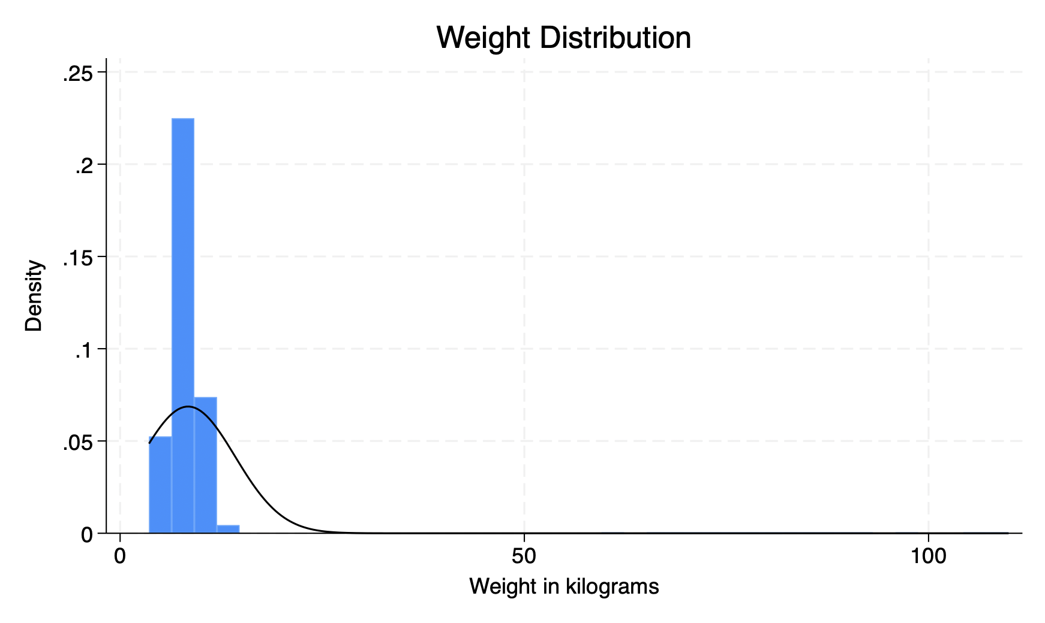
The weight distribution is right-skewed, with some outliers.

Figure 2.1-3. Height by Gender
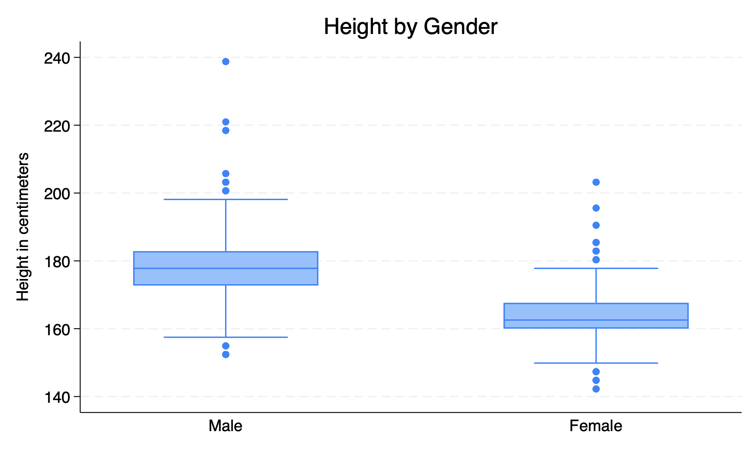
Males are generally taller than females.
Figure 2.1-4. Weight by Component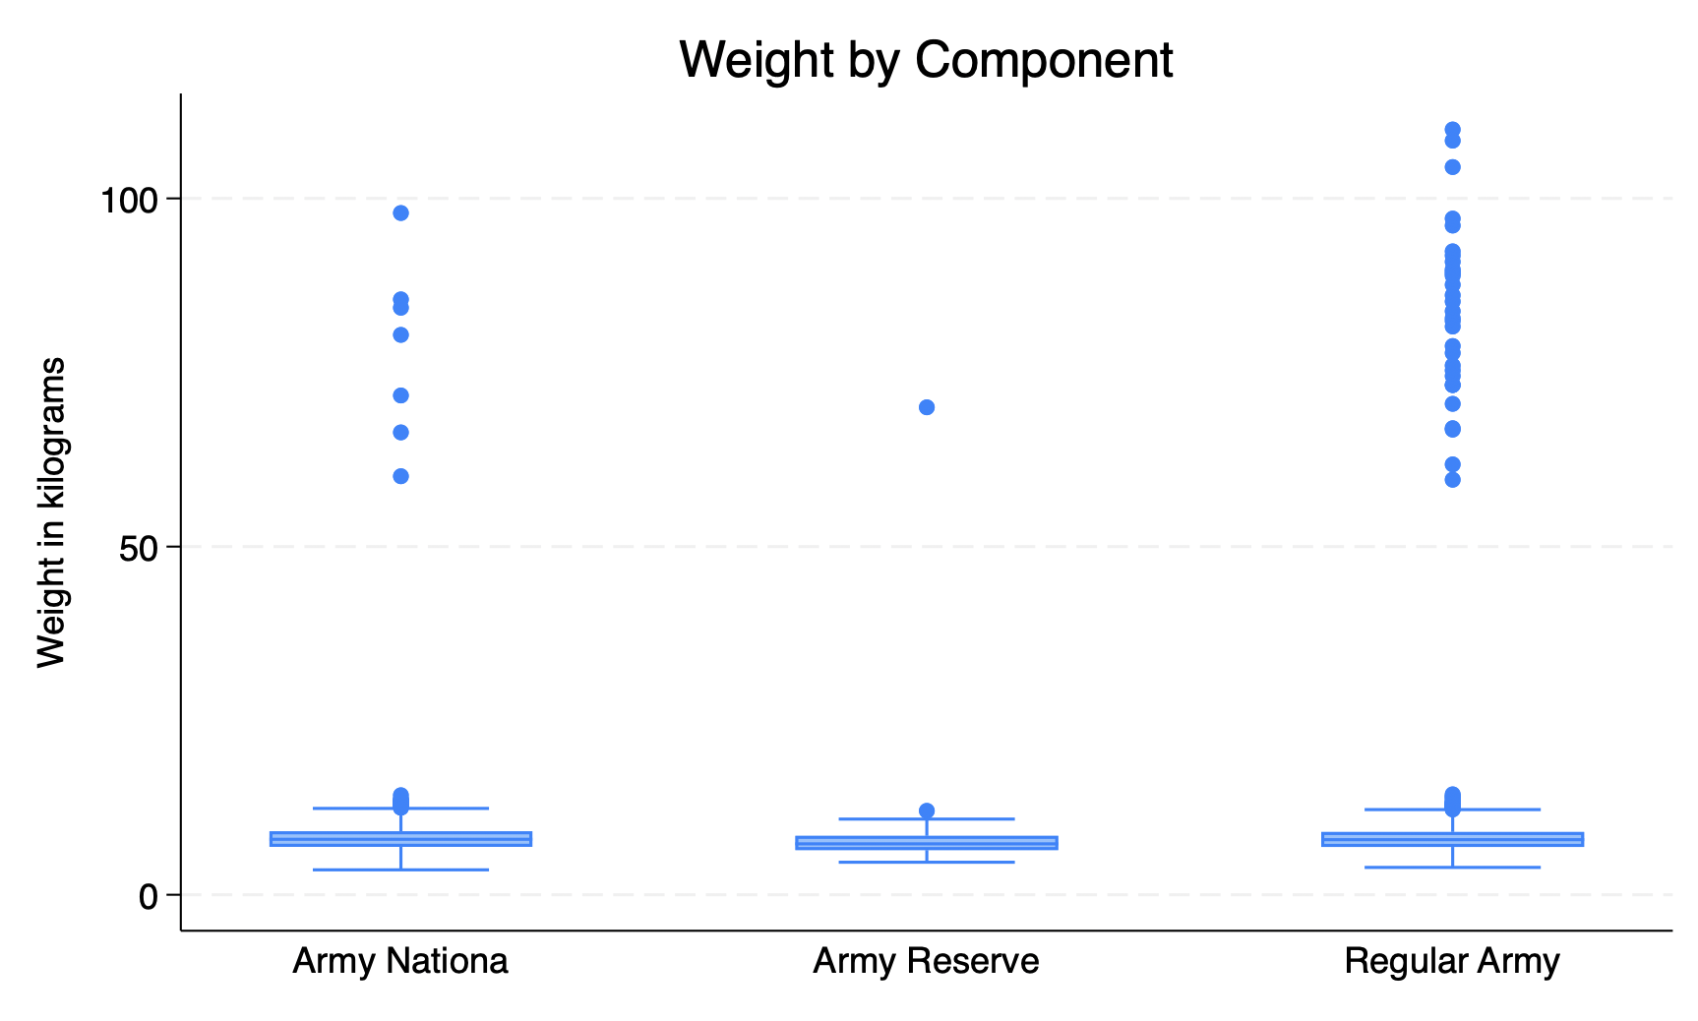
Weight varies slightly across Army components.

3. Anthropometric Measures
Key anthropometric measurements showed that the average stature was 1716.33 mm (SD = 92.24), the mean waist circumference was 916.74 mm (SD = 114.58), and the mean chest circumference was 1024.72 mm (SD = 101.08). These results reflect substantial variation in body size and composition across individuals in the sample. Chest and waist circumferences showed greater variability than stature, suggesting greater heterogeneity in body composition than in height.
Table 3.1-1. Key Anthropometric Measures
Variable | Mean | SD
Stature (mm) | 1716.33 | 92.24
Waist Circumference | 916.74 | 114.58
Chest Circumference | 1024.72 | 101.08

3.1a Data Quality Assessment
Data quality checks identified a small number of implausible values. Specifically, 40 observations (0.57%) were flagged for unrealistic weight values and recoded as missing to prevent distortion of the results. Similar checks were applied to height. Overall, the dataset was of high quality with minimal problematic values.

3.1b Body Proportion Differences by Sex

Figure 3.1-1. Percent Height to Hip by Gender
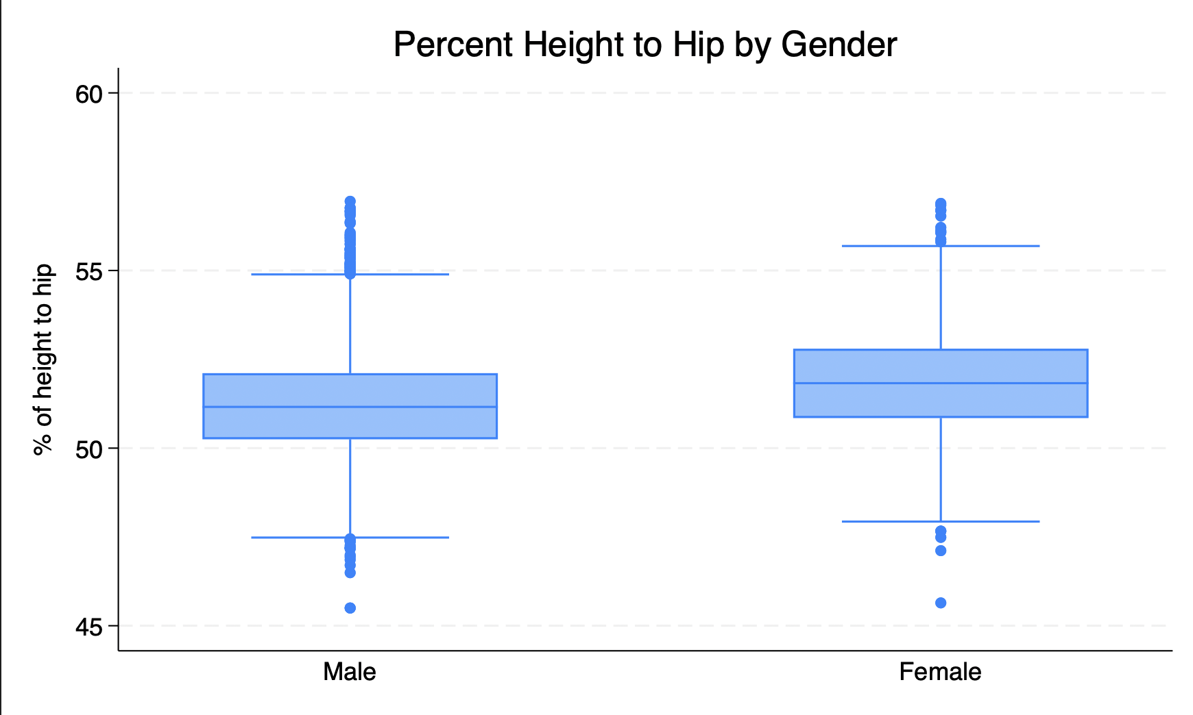

The proportion of height attributed to hip height was calculated using trochanterion height relative to stature. The boxplot shows that females tend to have a slightly higher percentage compared to males, indicating modest differences in body proportions, with females having relatively longer lower body segments.

4. Stratified Analysis
Stratified analyses revealed clear differences by gender. Males were taller (mean = 177.92 cm) and heavier (mean = 90.89 kg) compared to females (mean height = 164.01 cm; mean weight = 69.11 kg). Males also had larger anthropometric measurements, including waist and chest circumferences. Differences were also observed across Army components. Regular Army and National Guard participants had similar height and weight distributions, while Army Reserve participants tended to have slightly lower average measurements.

Table 4.0-1. Stratified Analysis by Gender

Variable | Male Mean | Female Mean
Height (cm) | 177.92 | 164.01
Weight (kg) | 90.89 | 69.11

Table 4.0-2. Stratified Analysis by Army Component

Component | Height (cm) | Weight (kg)
Regular Army | 173.72 | 86.13
National Guard | 173.85 | 82.32
Army Reserve | 169.69 | 76.33

4.1a Relationship between Measures of Stature
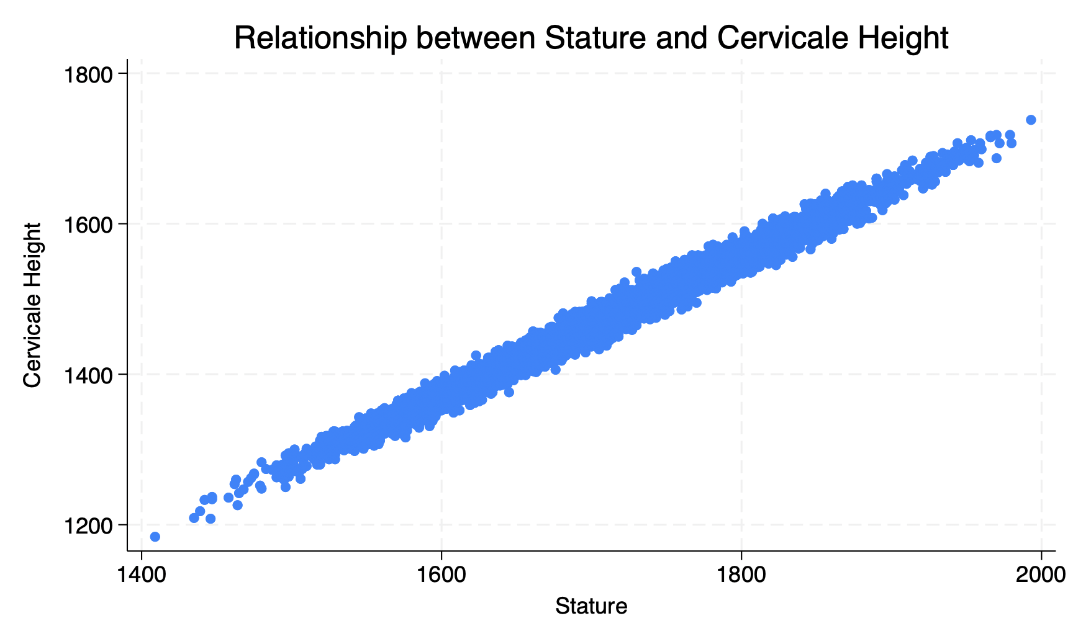
Figure 4.1-1. Relationship between Stature and Cervicale Height
Correlation analysis showed that stature and cervical height were the most highly correlated measures (r ≈ 0.99). The scatterplot demonstrates a very strong linear relationship between these two variables, indicating that cervical height is an excellent predictor of overall stature. All relationships were statistically significant (p < 0.001). The scatterplot confirms a strong linear relationship with minimal dispersion around the trend.
4.1b Correlations Among Anthropometric Measures (Males)
Table 4.1-1. Correlation Matrix for Males
Variable | Stature | Knee Height | Cervicale Height | Trochanterion Height | Functional Leg Length | Span
Stature | 1.000 | 0.833 | 0.984 | 0.853 | 0.812 | 0.823
Knee Height | 0.833 | 1.000 | 0.856 | 0.901 | 0.803 | 0.800
Cervicale Height | 0.984 | 0.856 | 1.000 | 0.872 | 0.841 | 0.839
Trochanterion Height | 0.853 | 0.901 | 0.872 | 1.000 | 0.807 | 0.814
Functional Leg Length | 0.812 | 0.803 | 0.841 | 0.807 | 1.000 | 0.783
Span | 0.823 | 0.800 | 0.839 | 0.814 | 0.783 | 1.000
Among males, stature was strongly correlated with all other anthropometric measures. The strongest correlation was observed with cervical height (r ≈ 0.98), followed by knee height and trochanterion height. All correlations were statistically significant (p < 0.001). These findings indicate that body measurements scale consistently with stature, with cervical height serving as the strongest predictor of overall height.

4.1c Correlations Among Anthropometric Measures (Females)
Table 4.1-2. Correlation Matrix for Females
Variable | Stature | Knee Height | Cervicale Height | Trochanterion Height | Functional Leg Length | Span
Stature | 1.000 | 0.841 | 0.985 | 0.859 | 0.832 | 0.820
Knee Height | 0.841 | 1.000 | 0.864 | 0.915 | 0.827 | 0.828
Cervicale Height | 0.985 | 0.864 | 1.000 | 0.879 | 0.849 | 0.832
Trochanterion Height | 0.859 | 0.915 | 0.879 | 1.000 | 0.843 | 0.841
Functional Leg Length | 0.832 | 0.827 | 0.849 | 0.843 | 1.000 | 0.815
Span | 0.820 | 0.828 | 0.832 | 0.841 | 0.815 | 1.000
Among females, stature was also strongly correlated with all other anthropometric measures. The strongest correlation was observed with cervical height (r ≈ 0.98), followed by knee height and trochanterion height. All correlations were statistically significant (p < 0.001). These findings indicate consistent scaling of body measurements with stature, similar to patterns observed in males.
4.2 Differences by Gender
Independent t-tests were conducted to examine differences in stature by gender. Results showed that males had significantly greater stature (mean = 1756.59 mm) than females (mean = 1627.76 mm). The difference in means was 128.83 mm and was statistically significant (p < 0.001). These findings indicate that gender is a strong predictor of stature in this population.

Figure 4.2-1. Weight Difference Histogram
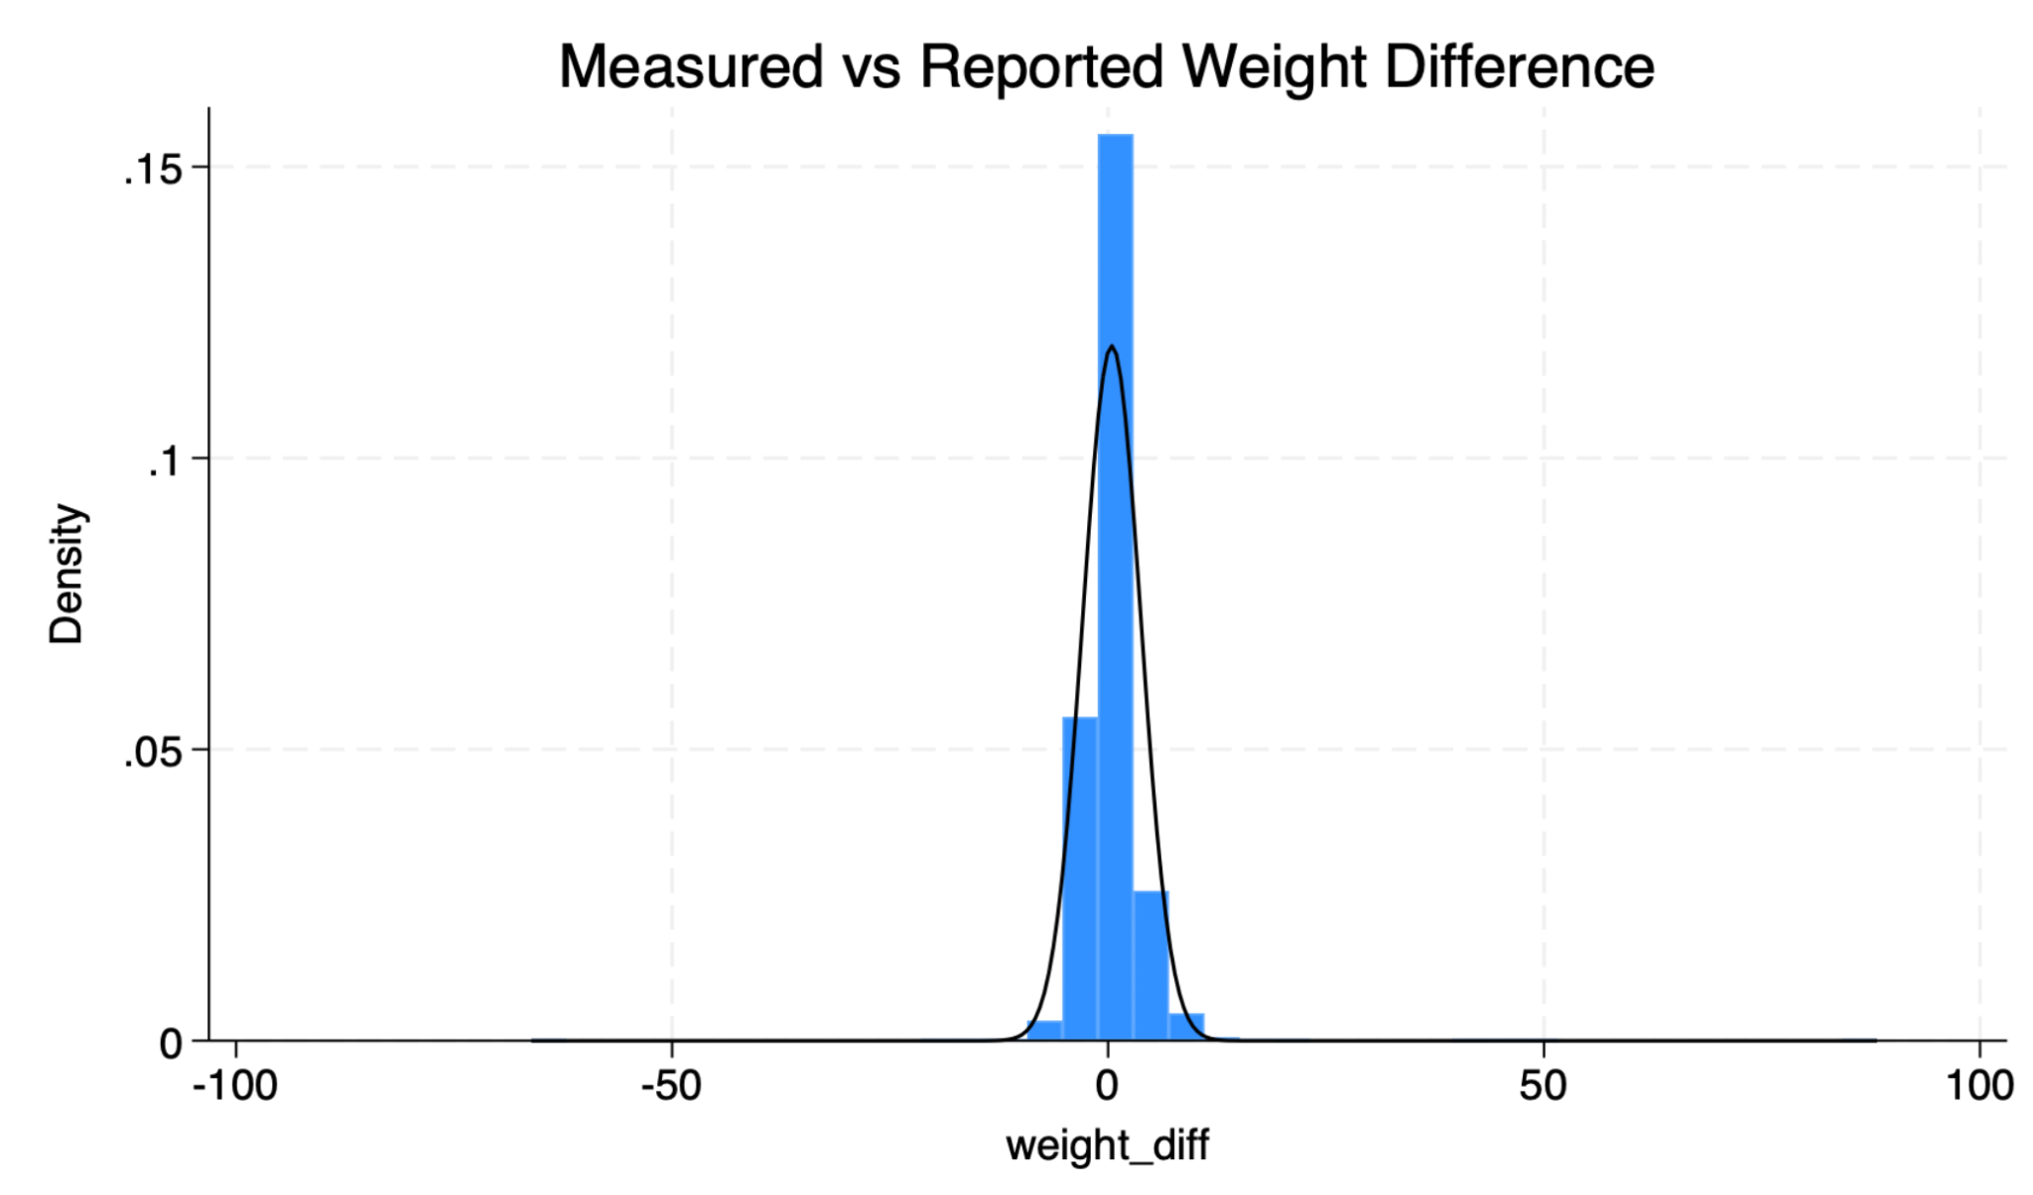
The distribution of weight differences (measured minus reported) is centered slightly above zero, indicating that participants tend to underreport their weight on average. Most observations cluster near zero, suggesting small discrepancies, though a few extreme values indicate substantial underreporting or overreporting in some individuals.

Figure 4.2-2. Weight Difference by Gender
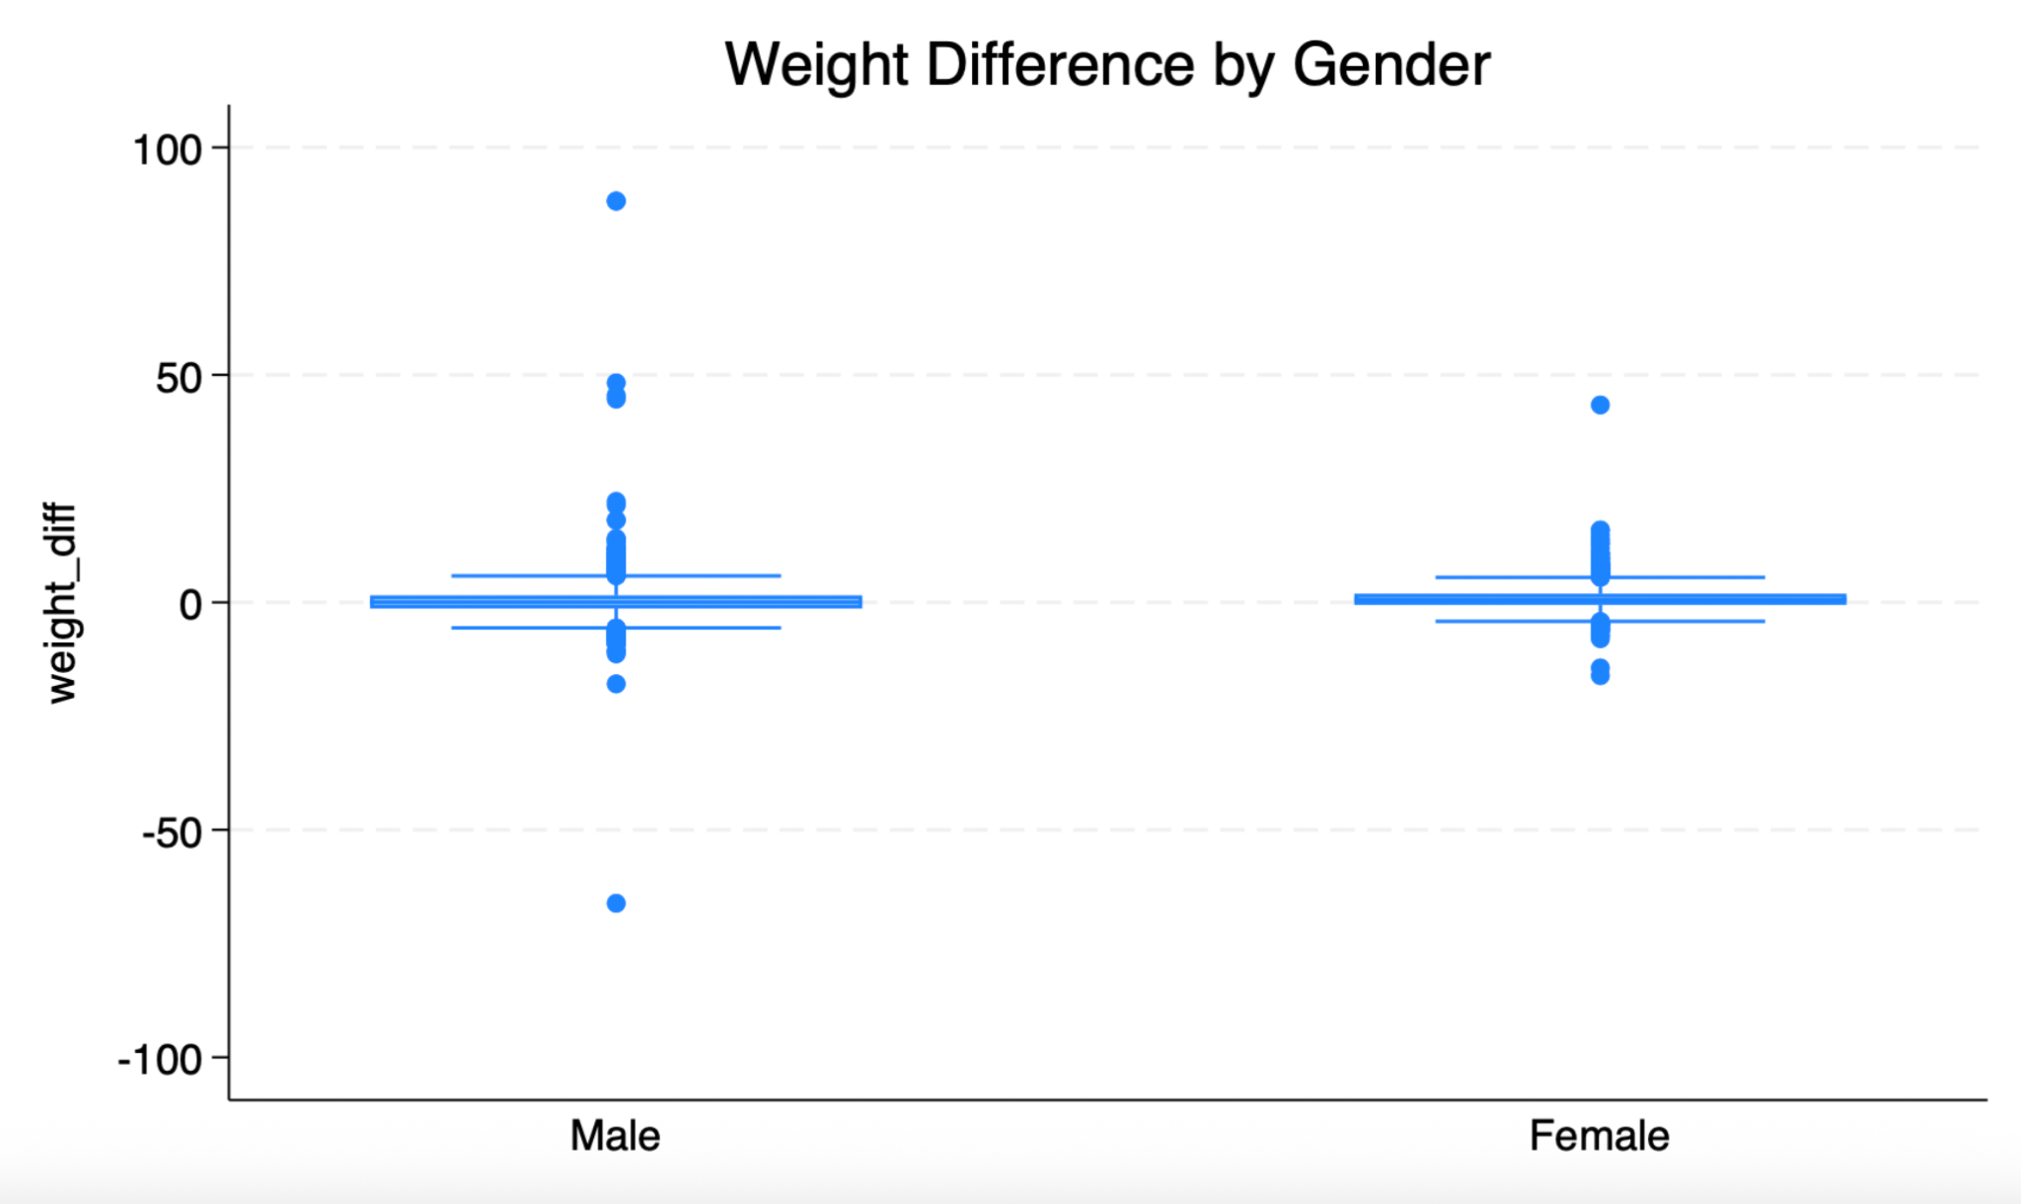

The distribution of weight differences is similar for males and females, with both groups showing values centered near zero. However, males exhibit slightly greater variability and more extreme values, suggesting a wider range of reporting discrepancies compared to females.

Figure 4.2-3. Height Difference Histogram
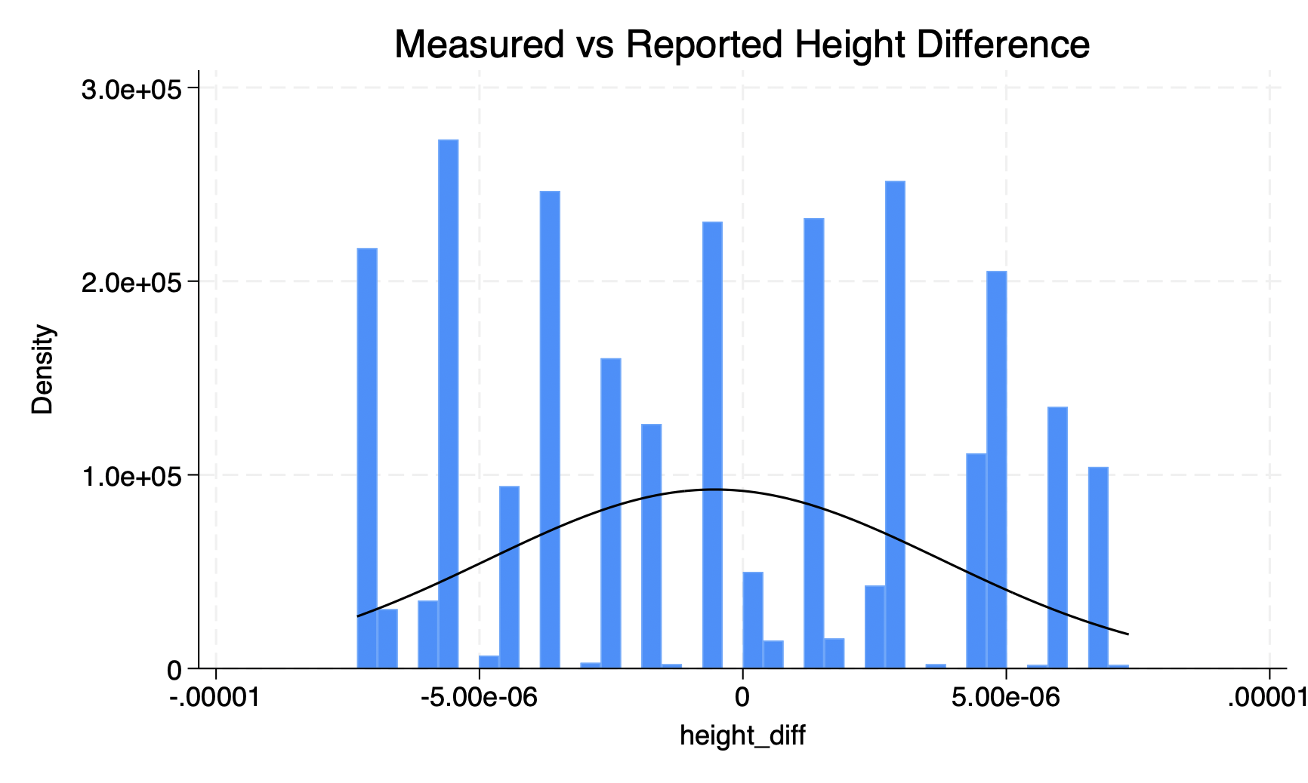
Differences between measured and reported height are minimal and tightly clustered around zero. This indicates that participants report their height with relatively high accuracy and very little systematic bias, compared to weight.

4.3 Differences by Age Group
Table 4.3-1. Mean Stature by Age Group

Age Group | Mean Stature (mm) | SD | N
18–24 | 1710.66 | 90.86 | 2,399
25–44 | 1719.78 | 89.25 | 4,088
45–64 | 1718.76 | 86.36 | 541
Total | 1716.59 | 89.68 | 7,028

Analysis of variance (ANOVA) was conducted to examine differences in stature across age groups. Table 4.3-1 summarizes the mean stature across age categories. Results indicated statistically significant differences in stature across age groups (F = 1.81, p = 0.0014). However, the magnitude of these differences was small, with mean stature remaining relatively consistent across groups. This suggests that while age differences are statistically detectable, they are not practically meaningful within this adult population.

5. Body Mass Index (BMI)
Body Mass Index (BMI) was calculated using measured height and weight. The mean BMI in the sample was 26.43 (SD = 3.96), indicating that, on average, it fell within the overweight range. The majority of participants were classified as overweight (44.19%) or normal weight (36.63%), while fewer individuals were classified as obese (18.34%) or underweight (0.84%). These results suggest that a large proportion of the sample falls above the normal BMI range.

Table 5.1-1. BMI Categories
BMI Category | Frequency | Percent
Underweight | 59 | 0.84%
Normal | 2,575 | 36.63%
Overweight | 3,106 | 44.19%
Obese | 1,289 | 18.34%

5.1 BMI and Age
Figure 5.1-1. BMI by Age Group
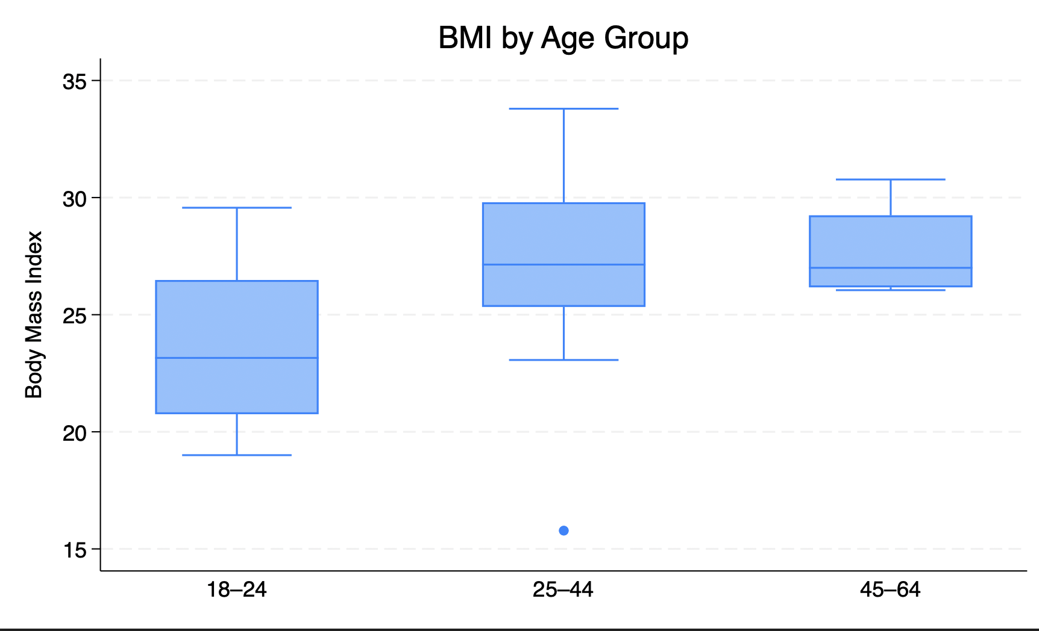
Median BMI increases with age, with older individuals showing higher values.

Table 5.1-2. Mean BMI by Age Group

Age Group | Mean BMI | SD | N
18–24 | 23.53 | 3.31 | 13
25–44 | 27.36 | 4.00 | 22
45–64 | 27.70 | 2.17 | 4
Total | 26.12 | 4.01 | 39

BMI was further examined in relation to age. Scatterplots of BMI versus age, stratified by sex, show a slight positive relationship, with BMI tending to increase with age, although the relationship appeared relatively weak.
When age was categorized, individuals in the 25–44 and 45–64 age groups had higher mean BMI values compared to those aged 18–24. This pattern is also reflected in the boxplot, where older age groups show higher median BMI. Overall, these findings suggest that BMI increases modestly with age in this sample.
6. Conclusion
Altogether, the anthropometric data in this data set showed high internal consistency and predicted biological trends. Stature was strongly associated with various body measurements, especially with cervical height. The discrepancies between measured and self-reported values were low for height but stronger for weight, suggesting a reporting bias.
Body types defined by waist-to-height ratio were usually consistent with BMI type and provided further information on fat distribution. Age analysis revealed statistically significant, yet practically small, differences in stature. Furthermore, BMI tended to increase with age, though only slightly.
All in all, these results underscore the importance of using two or more anthropometric measurements to determine body composition and demonstrate the usefulness of both measured and computed variables in the study of population health.

Appendix
Appendix A. Stata Do-File
* Name: Sarah Mzee
* Course: PBHLT 7101
* Assignment: Project 1 – ANSUR II Analysis
* Date: March 12, 2026

clear all
set more off

cd "~/Desktop"
use "ansur2allV2.dta", clear

* INITIAL CHECKS
describe
codebook
tab age

drop if age < 18
summ age

* RECODE MISSING (-99 to .a)
foreach var in thumbtipreach span footlength kneeheightmidpatella ///
waistheightomphalion functionalleglength cervicaleheight ///
trochanterionheight stature waistcircumference ///
chestcircumference bicristalbreadth hipbreadth ///
hipbreadthsitting weightkg {
replace `var' = .a if `var' == -99
}

* CREATE VARIABLES
gen weight_kg = weightkg/10
label variable weight_kg "Weight in kilograms"

gen height_cm = heightin * 2.54
label variable height_cm "Height in centimeters"

* FLAG SUSPECT VALUES
gen suspect_weight = 0
replace suspect_weight = 1 if weight_kg < 35 | weight_kg > 250
replace weight_kg = .b if suspect_weight == 1
label variable suspect_weight "Flag: suspect weight"

gen suspect_height = 0
replace suspect_height = 1 if height_cm < 120 | height_cm > 230
replace height_cm = .b if suspect_height == 1
label variable suspect_height "Flag: suspect height"

gen suspect_flag = 0
replace suspect_flag = 1 if suspect_weight == 1 | suspect_height == 1
label variable suspect_flag "Any suspect value"

tab suspect_weight
tab suspect_height
tab suspect_flag

* BMI
gen bmi = weight_kg / ((height_cm/100)^2)
label variable bmi "Body Mass Index"

gen bmi_cat = .
replace bmi_cat = 1 if bmi < 18.5
replace bmi_cat = 2 if bmi >= 18.5 & bmi < 25
replace bmi_cat = 3 if bmi >= 25 & bmi < 30
replace bmi_cat = 4 if bmi >= 30

capture label define bmilbl 1 "Underweight" 2 "Normal" 3 "Overweight" 4 "Obese"
label values bmi_cat bmilbl

tab bmi_cat

* CLEAN CATEGORICAL VARIABLES
gen female = .
replace female = 1 if gender == "Female"
replace female = 0 if gender == "Male"

capture label define femlbl 0 "Male" 1 "Female"
label values female femlbl

gen comp = .
replace comp = 1 if component == "Regular Army"
replace comp = 2 if component == "Army Reserve"
replace comp = 3 if component == "Army Nationa"

capture label define complbl 1 "Regular Army" 2 "Army Reserve" 3 "National Guard"
label values comp complbl

* DESCRIPTIVES
tab female
tab comp
summ age
summ height_cm weight_kg
summ stature waistcircumference chestcircumference

tabstat height_cm weight_kg stature waistcircumference ///
chestcircumference, by(female) stat(mean sd min max)

tabstat height_cm weight_kg stature waistcircumference ///
chestcircumference, by(comp) stat(mean sd min max)

* FIGURES
histogram height_cm, normal
histogram weight_kg, normal

graph box height_cm, over(female)
graph box weight_kg, over(comp)

* ANALYSIS
pwcorr stature kneeheightmidpatella cervicaleheight ///
trochanterionheight functionalleglength span, sig

ttest stature, by(gender)

oneway stature age, tabulate

* DUPLICATE CHECK
capture drop dup_flag
duplicates tag subjectnumericrace, gen(dup_flag)
label variable dup_flag "Duplicate observation flag"

tab dup_flag

encode writingpreference, gen(write_pref)
label variable write_pref "Writing hand preference (encoded)"

tab write_pref

* Create month from date
gen month = month(date)

* Create season variable
gen season = .
replace season = 1 if inlist(month,12,1,2)
replace season = 2 if inlist(month,3,4,5)
replace season = 3 if inlist(month,6,7,8)
replace season = 4 if inlist(month,9,10,11)

label define seasonlbl 1 "Winter" 2 "Spring" 3 "Summer" 4 "Fall"
label values season seasonlbl
label variable season "Season of measurement"

tab season

* Body type based on waist-to-height ratio

gen whtr = waistcircumference / stature
label variable whtr "Waist-to-height ratio"

gen body_type = .

* Female cutoffs
replace body_type = 1 if whtr < 0.45 & female == 1
replace body_type = 2 if whtr >= 0.45 & whtr < 0.55 & female == 1
replace body_type = 3 if whtr >= 0.55 & female == 1

* Male cutoffs
replace body_type = 1 if whtr < 0.50 & female == 0
replace body_type = 2 if whtr >= 0.50 & whtr < 0.60 & female == 0
replace body_type = 3 if whtr >= 0.60 & female == 0

label define bodylbl 1 "Lean" 2 "Average" 3 "High Adiposity"
label values body_type bodylbl
label variable body_type "Body type classification"

tab body_type
* % of height from hip (trochanterionheight)

gen hip_height_pct = trochanterionheight / stature * 100
label variable hip_height_pct "% of height to hip"

* Compare by gender
graph box hip_height_pct, over(female) ///
title("Percent Height to Hip by Gender")

* Correlations for males
pwcorr stature kneeheightmidpatella cervicaleheight ///
trochanterionheight functionalleglength span if female==0, sig

* Correlations for females
pwcorr stature kneeheightmidpatella cervicaleheight ///
trochanterionheight functionalleglength span if female==1, sig

twoway scatter cervicaleheight stature, ///
title("Relationship between Stature and Cervicale Height") ///
ytitle("Cervicale Height") xtitle("Stature")

* Weight difference (measured - reported)
gen weight_diff = weight_kg - (weightlbs * 0.453592)
gen height_diff = height_cm - (heightin * 2.54)
summ weight_diff height_diff

summ weightlbs weight_kg

drop weight_kg
gen weight_kg = weightkg / 10
label variable weight_kg "Weight in kilograms"

